**SRM INSTITUTE OF SCIENCE AND TECHNOLOGY**

**DEPARTMENT OF COMPUTER SCIENCE AND ENGINEERING**

**KATTANKULATHUR – 603 203**

**15IT304J- Web Programming Register Number: RA1711003011471**

**Name: Manvi Singh Chandel**

**Experiment No: 5**

**Date: 11/09/2020**

**Aim:** **Write a PHP Script for login authentication. Design an html form which takes username and password from user and validate against stored username and password in file**

**Input:**

**PHP Code:-**

<!DOCTYPE html>

<html>

<head>

<meta charset="utf-8">

<title>Login</title>

<link rel="stylesheet" href="https://use.fontawesome.com/releases/v5.7.1/css/all.css">

</head>

<body>

<div class="login">

<h1>Login</h1>

<form action="authenticate.php" method="post">

<label for="username">

<i class="fas fa-user"></i>

</label>

<input type="text" name="username" placeholder="Username" id="username" required>

<label for="password">

<i class="fas fa-lock"></i>

</label>

<input type="password" name="password" placeholder="Password" id="password" required>

<input type="submit" value="Login">

</form>

</div>

</body>

</html>

**CSS Code:-**

{

box-sizing: border-box;

font-family: -apple-system, BlinkMacSystemFont, "segoe ui", roboto, oxygen, ubuntu, cantarell, "fira sans", "droid sans", "helvetica neue", Arial, sans-serif;

font-size: 16px;

-webkit-font-smoothing: antialiased;

-moz-osx-font-smoothing: grayscale;

}

body {

background-color: #435165;

}

.login {

width: 400px;

background-color: #ffffff;

box-shadow: 0 0 9px 0 rgba(0, 0, 0, 0.3);

margin: 100px auto;

}

.login h1 {

text-align: center;

color: #5b6574;

font-size: 24px;

padding: 20px 0 20px 0;

border-bottom: 1px solid #dee0e4;

}

.login form {

display: flex;

flex-wrap: wrap;

justify-content: center;

padding-top: 20px;

}

.login form label {

display: flex;

justify-content: center;

align-items: center;

width: 50px;

height: 50px;

background-color: #3274d6;

color: #ffffff;

}

.login form input[type="password"], .login form input[type="text"] {

width: 310px;

height: 50px;

border: 1px solid #dee0e4;

margin-bottom: 20px;

padding: 0 15px;

}

.login form input[type="submit"] {

width: 100%;

padding: 15px;

margin-top: 20px;

background-color: #3274d6;

border: 0;

cursor: pointer;

font-weight: bold;

color: #ffffff;

transition: background-color 0.2s;

}

.login form input[type="submit"]:hover {

background-color: #2868c7;

transition: background-color 0.2s;}

**OUTPUT:-**

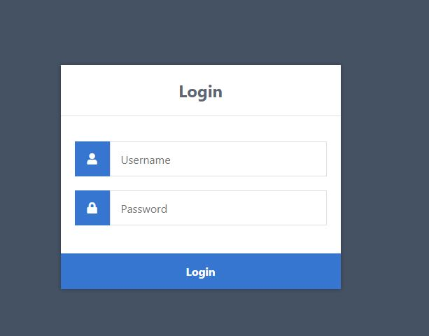

**Result: A Php script for login authentication done successfully.**